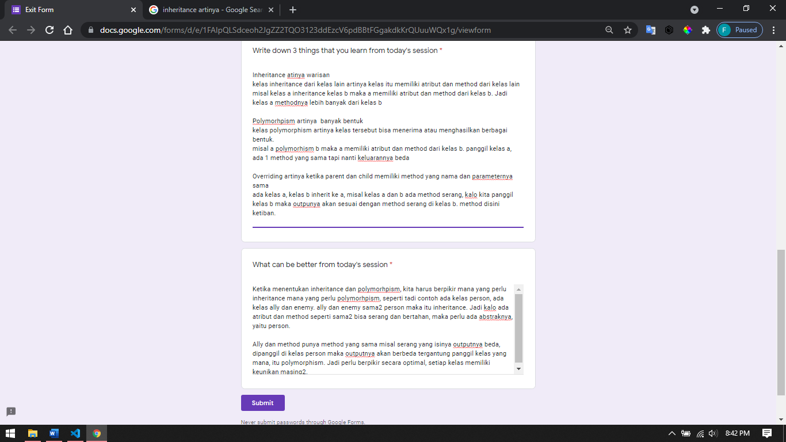

Inheritance

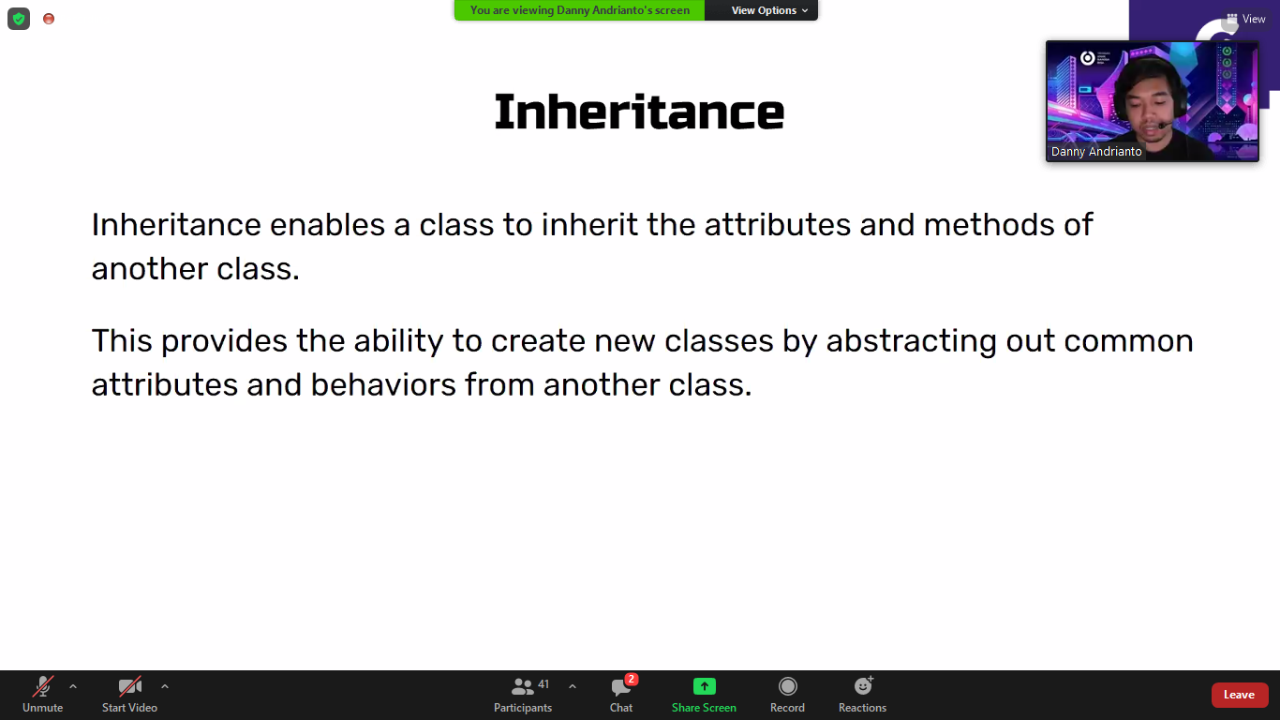

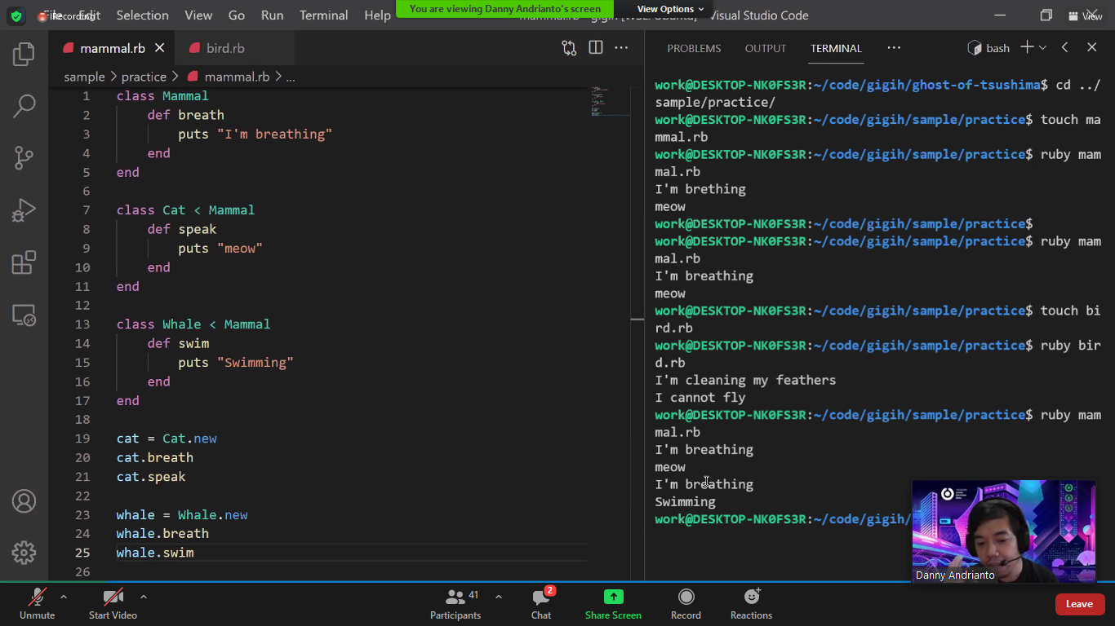

Si whale kalo mau parentnya lebih bisa dengan inherit lagi dengan ikan bar uke whale

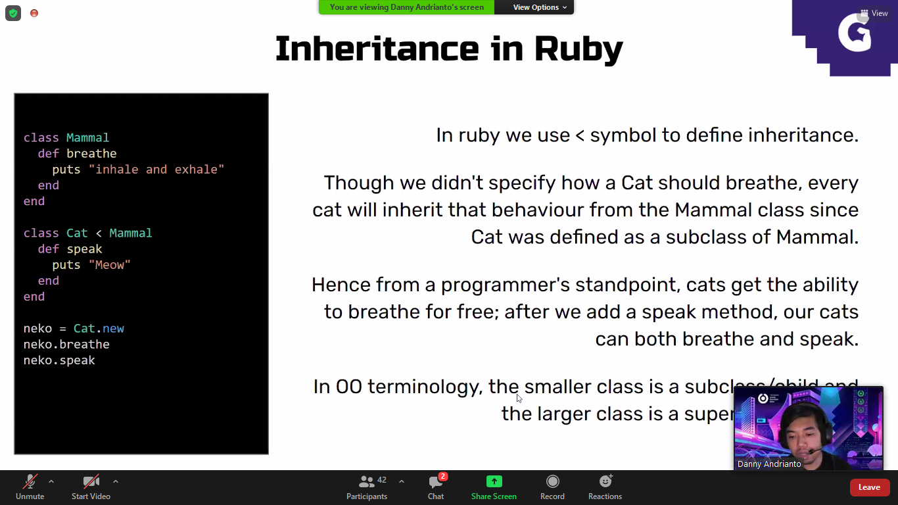

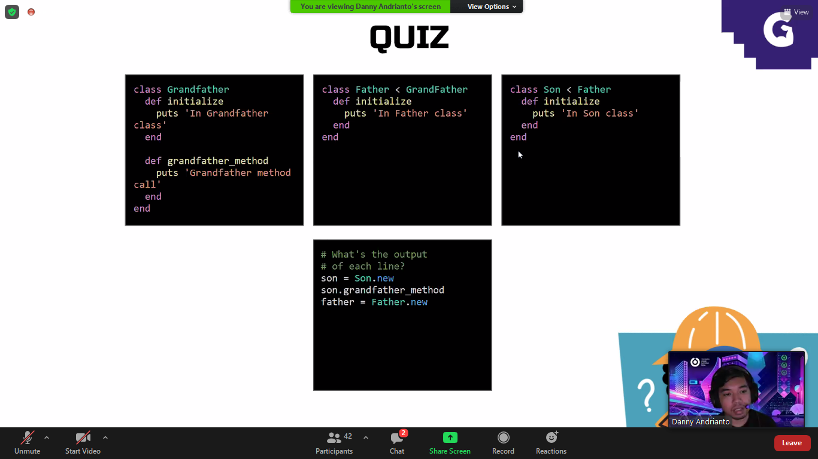

Ini hasilnya

In son class -> overriding karena nama method sama yaitu initialzie

Grandfather method -> panggil method

In father class -> overrinding

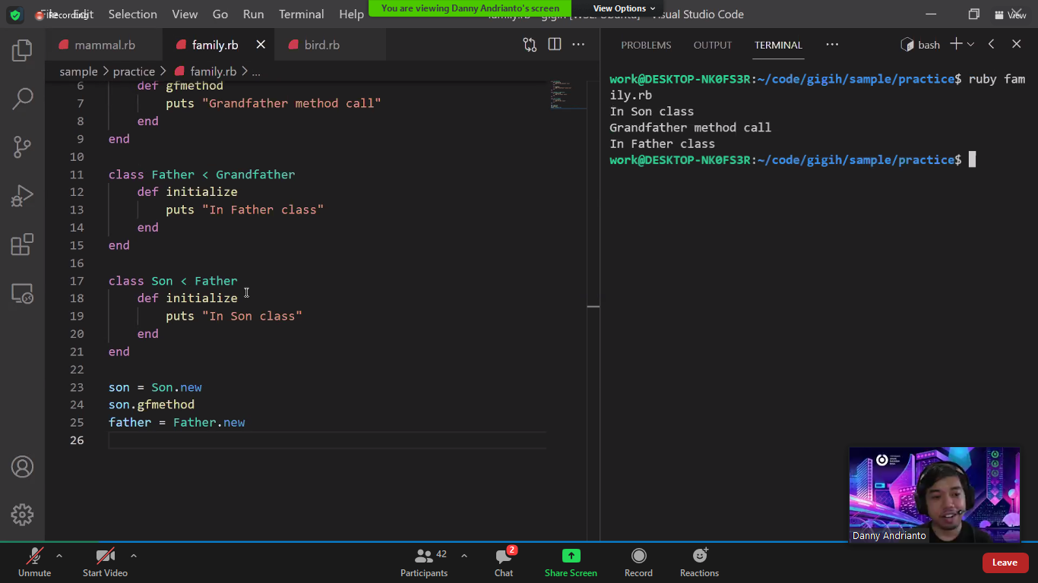

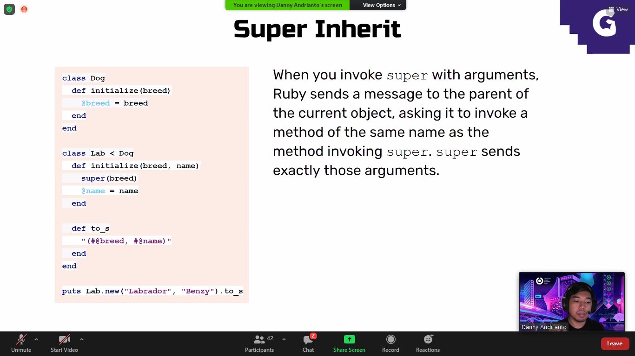

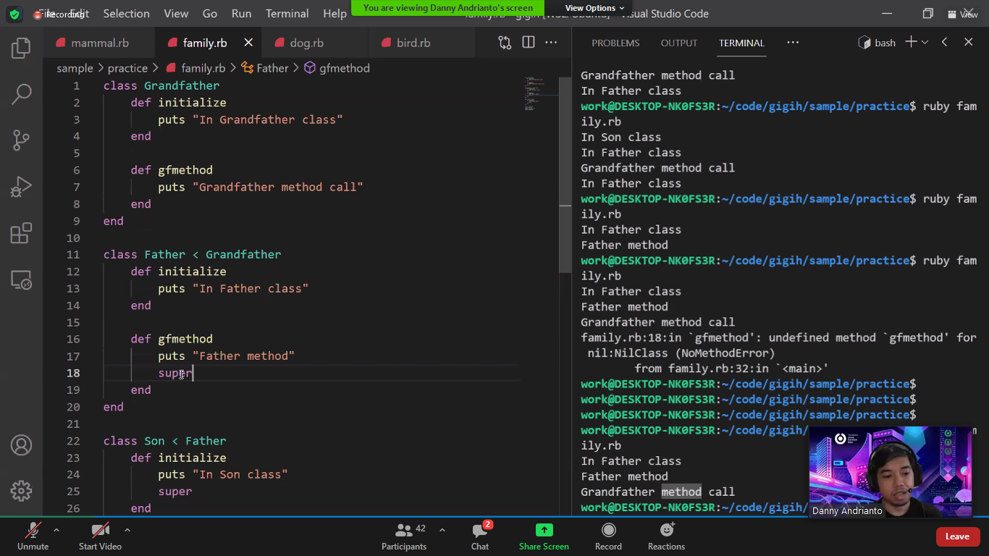

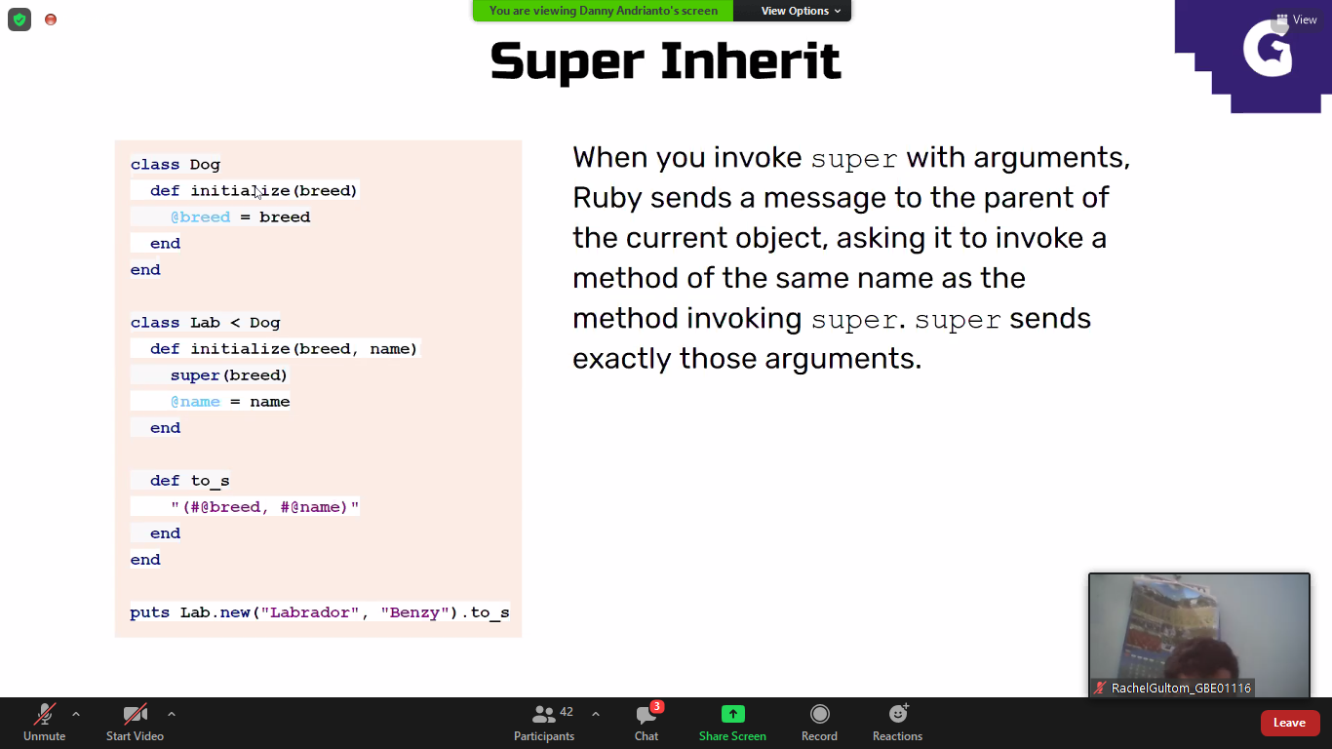

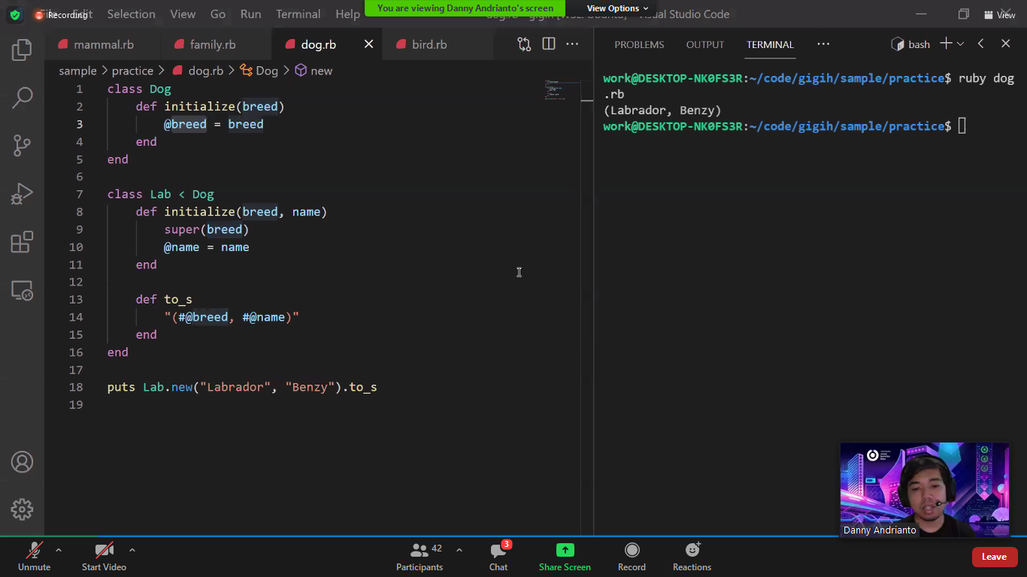

Require dan require relative

Require ./ bisa 1 folder

Require relative 1 file

Inheritance is one in which a new class is created that inherits the properties of the already exist class. It supports the concept of code reusability and reduces the length of the code in object-oriented programming.

Class parent

kaki

Class child < parent

Tangan

Parent punya kaki

Child punya kaki dan tangan

Kaki reusable

Plymorpism

Polymorphism is that in which we can perform a task in multiple forms or ways. It is applied to the functions or methods. Polymorphism allows the object to decide which form of the function to implement at compile-time as well as run-time.

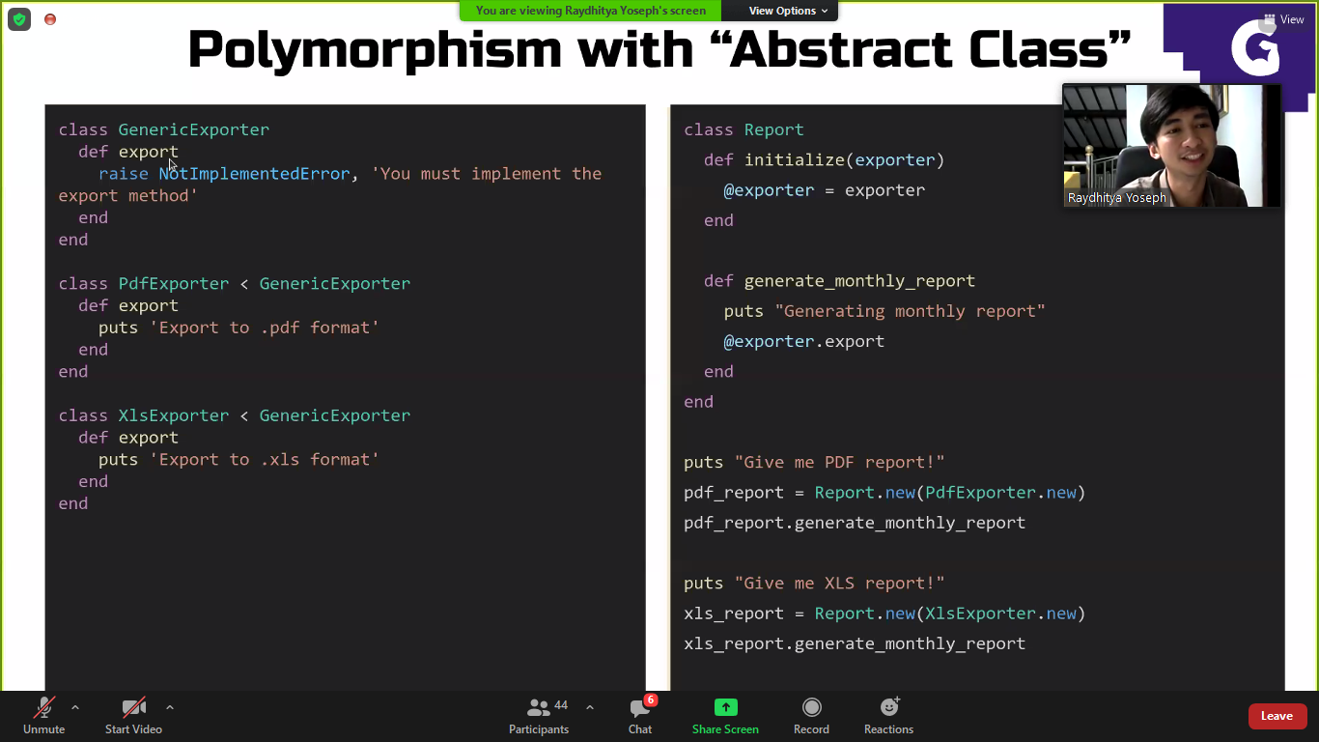

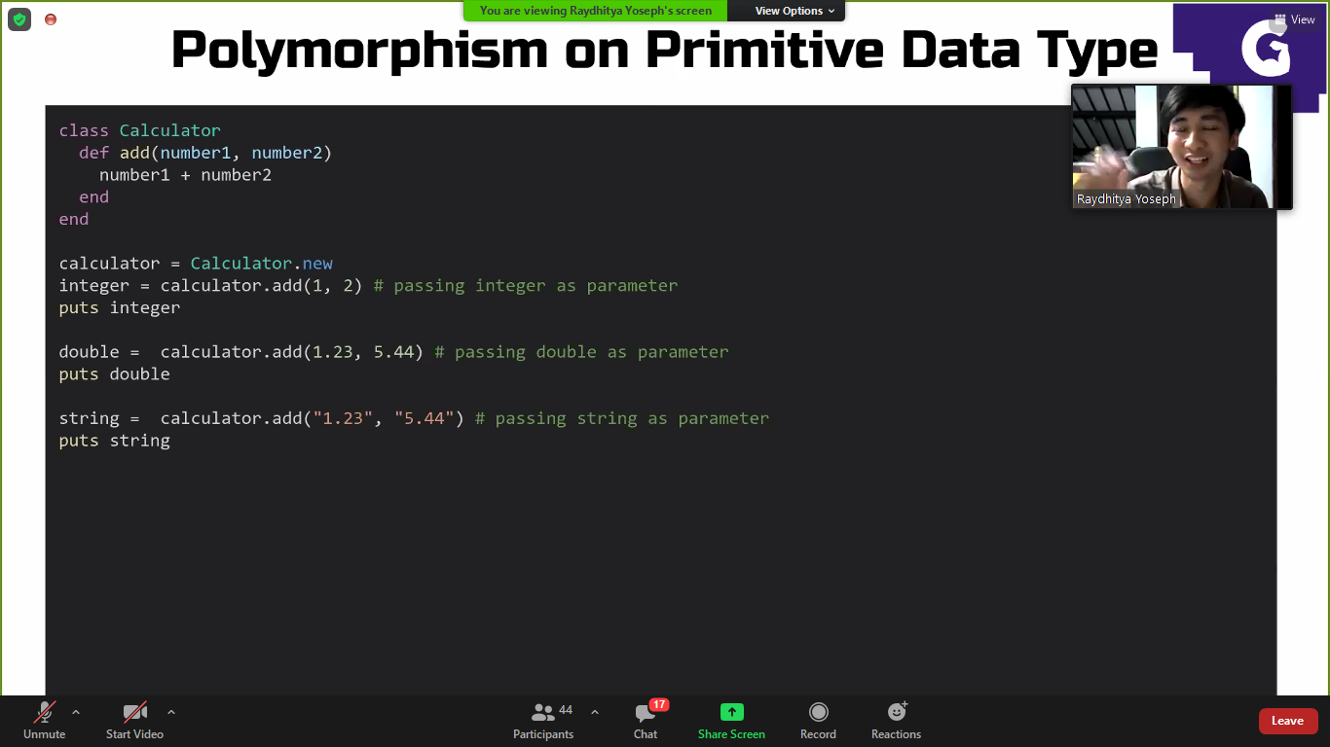

Parameternya polymoph juga

Tanda tambah juga ploymoroph

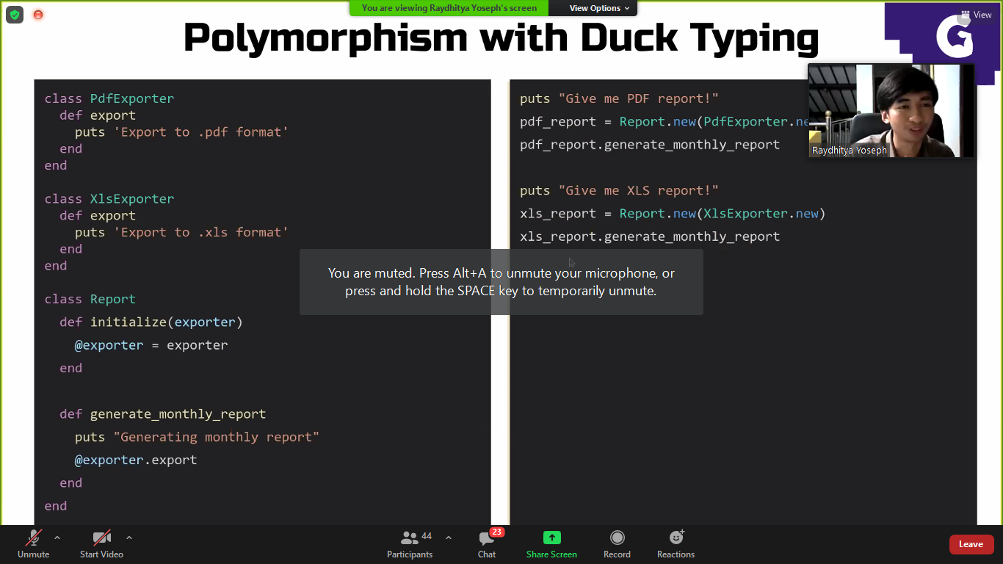

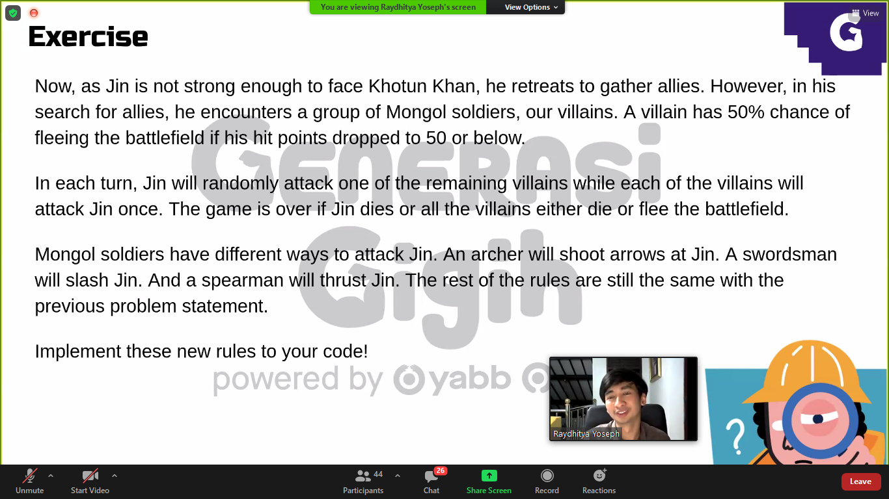

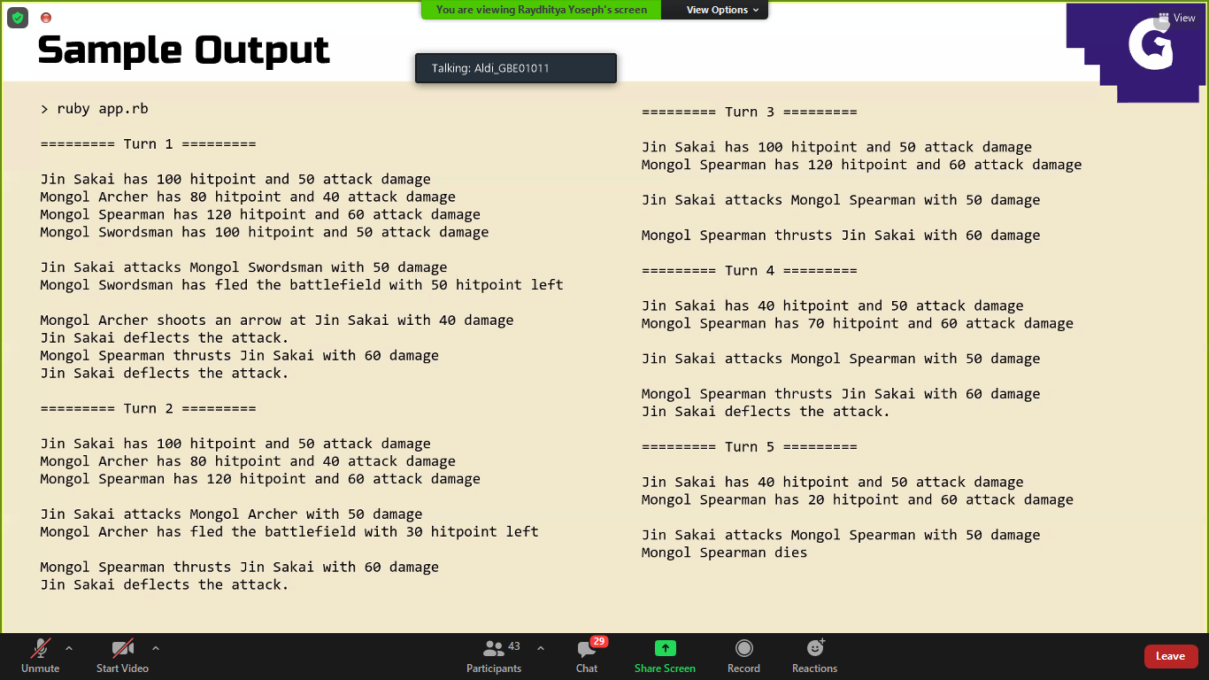

Pr nya ditambah, pake berkuda, masukin pake tipe variable, dan dilihat perbedaan pake tipe dan pake kelas

Dynamic dispatch

Dalm kelasnya di methodnya dapat menerima berbagai parameter dan atau memanipulasi berbagai ouput di kelas childnya

When two or more methods in the same class have the same name but different parameters, it’s called Overloading.

When the method signature (name and parameters) are the same in the superclass and the child class, it’s called Overriding.

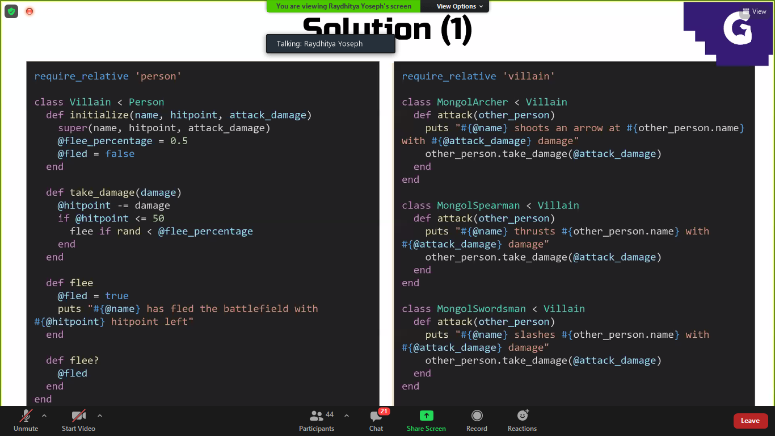

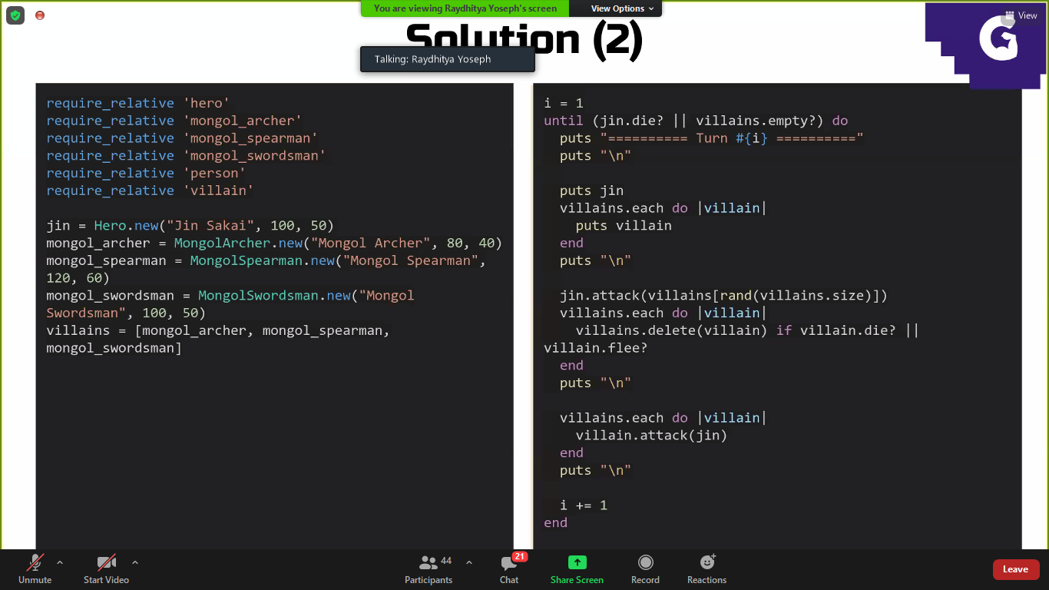

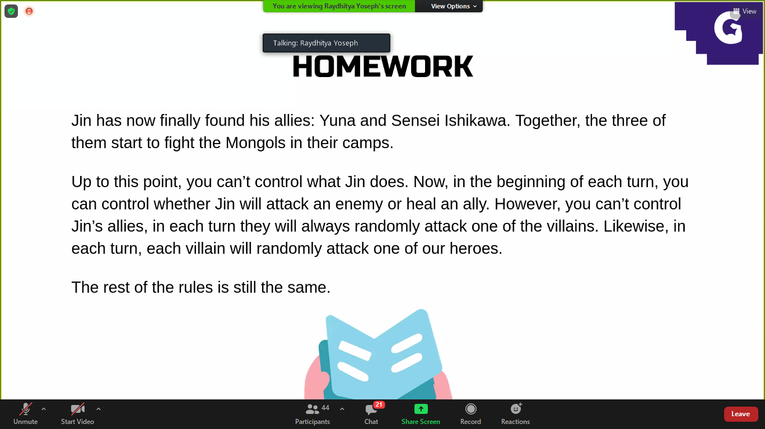

Pr nya jin bisa attack atau hill temenya

Hillnya 20

Jin bisa milih mau serang manathi

Semua mati baik ally maupun musuh maka the end

